Adoption Application Form | 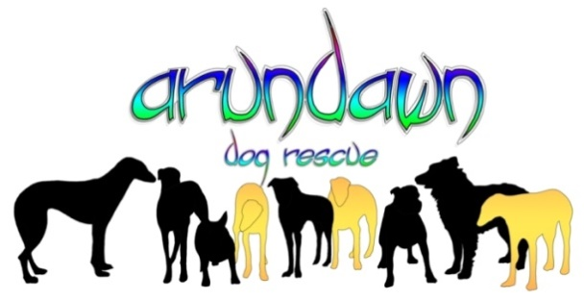

Date of Application:

What is the name of the dog you are applying for?

If this dog is not suitable please outline what sort of dog you are looking for?

Please be aware that the dog you may have applied for might not be available to adopt once your application has been assessed or may not be suitable to your current setup.

Section 1 – General Details

Full Name/s:
If a joint application, please enter both names here.

Age/s:

Full address including postcode:

Telephone numbers (give as many as possible):
Landline:
Mobile:
Alternative Mobile:

Email Address:

Details of all other occupants of your home:
Name/s:
Age/s:
Relationship to Adopter:

Section 2 – Family & Pets

Occupations for the all members of the household:

The normal days and hours of work for all members of the household:

Do you work from home regularly? If so, how often?

What is the longest period of time that any adopted dog will be left alone on a regular/ daily basis?

What is the longest period of time that any adopted dog will be left alone occasionally?

Do you have any plans to change your circumstances in the next 6-12 months? If so, please provide as much detail as possible.
For example – trying for a baby, pregnant (due date), returning to full-time work, moving house, adopting/fostering children etc. Also include any holidays with dates.

Other than your own children, do you have children visiting your house / garden regularly?

If yes, are these children dog experienced / used to dogs / not afraid of dogs?

Will all interactions between young children and the adopted dog always be supervised?

Do you own any other dogs?

If so, what are their breeds and gender? State whether neutered and a general description of their character.

How many hours of exercise / stimulation can you offer on a daily basis?

What do you currently feed your dog/s or previously fed?
Type and brand of food
Would you consider feeding a raw diet?
This may include mince, tripe, offal, fish, bone etc.

Is/Are your current dog/s vaccinations up to date?
We will require proof during the homecheck

Is/Are your current dog/s insured?
We will require proof during the homecheck

Are you prepared to insure any adopted dog?
If no, what provision will you make for large unforeseen vet fees or any public liability issues
Where would the dog sleep and what type of bed would you offer?

Do you own cats?

If yes, please give ages and indicate if they have lived with a dog before.

Do you own any other pets (e.g. house rabbits, caged rabbits, ferrets, rodents, birds, chickens, horses etc.)?

Are any small animals safely secured in suitable housing?

What arrangements will be made for the adopted dog if you have to go away / go on holiday / hospitalised?

Do you attend regular hospital appointments? If so, how frequently and, on average, how long do they take?

Section 3 – Home & Garden

Do you own your own home or rent?
If rented, we will need to see a Landlords letter, or email, on headed paper confirming their permission for you to keep the total number of dogs you are proposing to have.

Type of Home (e.g. GF Flat, Terraced, Semi):

How busy is the street on which the property is located?

Does the property open straight on to the street?

Does your home have a garden and if so, how big?

Is the garden totally secure and escape proof – no gaps in fences / hedges etc.?

Is the garden boundary fenced or is it hedged or a combination of the two?

How high are the fences / hedges surrounding your property?

How high are any gates? Are all gates secured? Can they be opened from outside the property?

Section 4 – Previous Experience & Training

Have you owned a dog before?

If yes, please give breeds and gender

Other than owning, what breeds have you any previous experience of (e.g. family dogs, breeds grown up with)?

Was/Were this dog /s adopted or purchased?

If adopted, from which rescue?

Do you wish to adopt a puppy, an adult or an older dog?

Do you have any previous experience of raising a puppy?

Would you consider adopting a dog with health issues?

Would you consider adopting two dogs needing a home together?

If your adopted dog developed behavioural issues, would you be willing to seek professional help?

Are you aware of the specific needs and character traits of the dog/breed you are applying for?

Are you willing to work through problems such as housetraining, basic training, recall etc.?

There can be no guarantees that any dog will be 100% house trained when moved. These are rescue dogs, some of whom have never lived in a house before coming into our care and, although every effort is made to house train these dogs in their adopt homes, this may not always be fully accomplished. You will be advised of our opinion only.

Are you willing to adopt a dog that cannot be let off a lead?

We can give no guarantee that any Arundawn dog will have recall. It may transpire that you may not be able to let your adopted /adopted dog off lead and Arundawn seeks reassurance that this will not be a problem for you.

Are you willing to adopt a dog who may need to be muzzled when other dogs are around?

Are you willing to take the dog to training classes, consult a behaviourist or work alongside Arundawn to rectify any settling in problems?

Please state in detail, what traits you ARE NOT prepared to accept? (e.g. jumping up, not fully housetrained etc.)

Dog Preference if any – Male or Female
Dog Preference if any – Type/Size
Dog Preference if any – Age

Section 5 – Other

Have you ever been homechecked by another rescue? If so, which rescue and what was the date?

Have you ever had to return a dog to rescue, relinquish a dog to rescue or rehome privately? If yes, please outline the circumstances.

Are you prepared to travel to meet / collect the dog /s you would like to adopt?

If so, how many miles are you prepared to travel?

Please give any other relevant information here:

Tell me why you would make the perfect forever home for the dog you are applying for?

All adopters must sign an Adoption Contract and agree the Terms and Conditions of Adoption.

The Adopter must insure the dog/bitch within 7 days of adoption.
Where possible we use microchips with dual registration and Arundawn remains a secondary/backup
contact for life.

All un-neutered dogs/bitches will be subject to the Adopter signing a Neutering Agreement.
All Adoption donations are compulsory, non-refundable and are not a purchase of said dog/bitch.

If you have any questions relating to this form or are unsure please do not hesitate to contact me on
07736 049390 or 01403 891687

Please send the completed form to arundawn.applications@btconnect.com

